**The First Few Hours Notes**

**Lesson 2: When should you fly?**

* 3 miles is the lowest practical visibility
* Always take off and land into the wind if possible
* **Cloud Ceiling** : The lowest cloud layer in the sky
  + Minimum Cloud Ceiling in VFR is 1000ft
  + **Overcast:** Complete cloud coverage
  + **Broken Ceiling**: Partial cloud coverage

**Lesson 3: Air Facts: Weather Geeks**

* Pilots can watch the morning news weather report, check the forecast and go online for the weather.
* You must stay constantly updated on the weather conditions before and during flight
* Pilots can also simulate decision making with respect to weather conditions using the programs.

**Lesson 5: Introduction to the Airplane**

* The Four forces acting on the plane: **Lift, Weight, Thrust, Drag**
* **Primary Source of lift**: The Bernoulli effect(Air above the wing speeds up and decreases pressure on the top surface)
* **Secondary Source of lift**: Air strikes the bottom of the wing and deflects downwards leading to increased pressure below via Newton’s third law.
* Airfoil Components:
  + **Leading edge:** The front of the airfoil
  + **Trailing edge:** Back of the airfoil
  + **Chord line:** The line connecting the leading and trailing edge
  + **Camber:** The curve of the wing, usually applied to only the top surface of the wing.
* **Airplane Axis of Rotation:**
  + **Longitudinal = Roll**
  + **Lateral = Pitch**
  + **Vertical = Yaw**

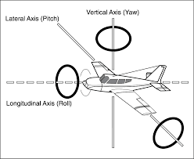

* **Control Inputs:**
  + **Ailerons:** Turning the yoke right raises the right aileron and lowers the left one in vice versa
  + **Elevator:** Applying back pressure to or pulling the yoke raises the elevator, which pitches the plane up. Applying front pressure lowers the elevator which pitches the plane down.
  + **Rudder:** Right Rudder pedal = Right rudder deflection and right yaw, Left Rudder pedal = Left Rudder deflection and left yaw
* **Adverse Yaw:** When banked the plane tends to yaw to the outside of the bank. Counteract this with rudder.
* **Trim Tabs:** Surfaces attached to the primary control surfaces to lower the workload on the pilot.
  + **Note:** The elevator trim can be adjusted using the trim wheel during flight. The rudder trim can only be adjusted on the ground.
* **Flaps:** Secondary Surfaces that increase the lift and drag on the wings when extended.

**Lesson 6: Introduction to the Flight Deck:**

* Traditionally the pilot flies the plane from the left
* **Three sections of a Cessna 172:** 
  + **Left** **Side:** flight, Navigation and engine instruments, electrical switches and circuit breakers.
  + **Middle:** Radios, Engine and fuel controls, Flaps and Trim
  + **Right Side:** Cabin Environment controls, Hour meter and space for options
* **The Flight Instruments:** 
  + Airspeed Indicator
  + Attitude Indicator
  + Altimeter
  + Turn Coordinator
  + Heading Coordinator (Directional Gyro)
  + Vertical Speed Indicator

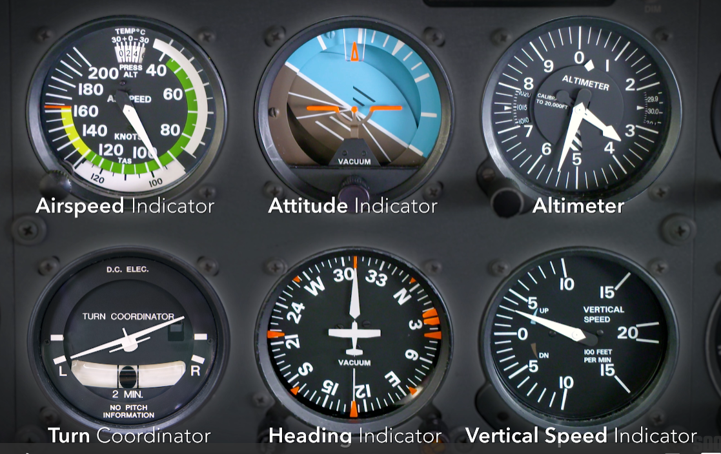

* 1 Statute Mile (SM) = 5280 ft , 1 Nautical Mile (NM) = 6076 ft
* 1 NM = 1.15 SM
* **Airspeed Indicator**
  + Measures the speed of the air moving around the plane in Nautical Miles per Hour (Knots)
  + **V­­S0:** Beginning of the White Arc and operating range for flaps and landing gear extended.
  + **V­­­­­­­­­­­S1:** Start of Green arc and Normal operation speed
  + **VFE:** Maximum speed allowed with flaps and landing gear extended
  + **VNO:** Start of the Yellow arc and the speed that should only be flown in smooth air.
  + **VNE:** Do not exceed or structural damage to plane. **Red Line**
  + **V­­X:** Speed for best **angle of climb**
  + **V­Y:** Speed for **Maximum rate of climb**

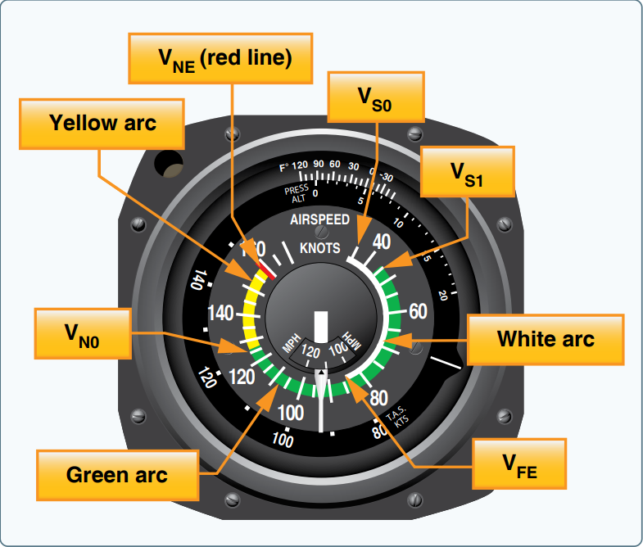

* **Vertical Speed Indicator:** Shows the climb or descent rate in 100s of ft per mintute

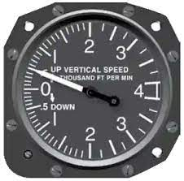

* **Altimeter:** Shows Indicated altitude using relation to a set pressure preset.
  + **Longest hand or Diamond:** 10,000s ft
  + **Shortest hand:** 1,000s ft
  + **Middle hand:** Fastest hand shows altitude in 100s ft
  + Must be adjusted before and during flight

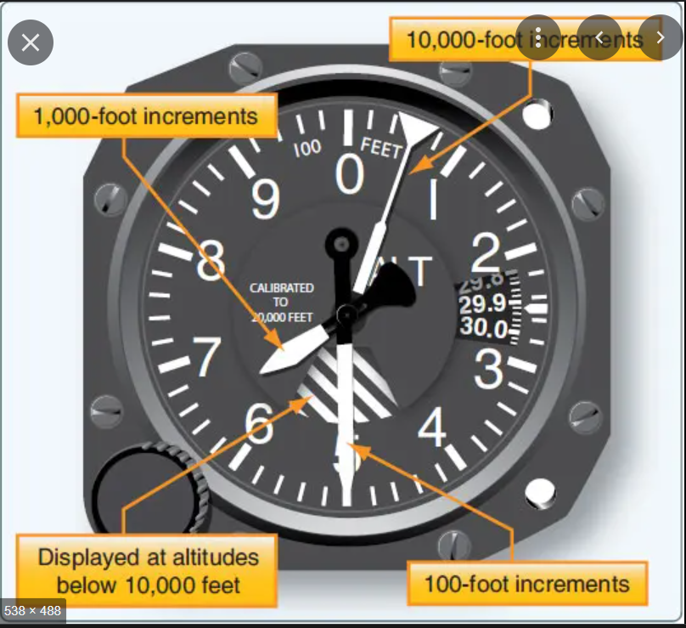

* **Attitude Indicator:** An artificial horizon which is gyroscopically stabilized to show your angle of bank and pitch.

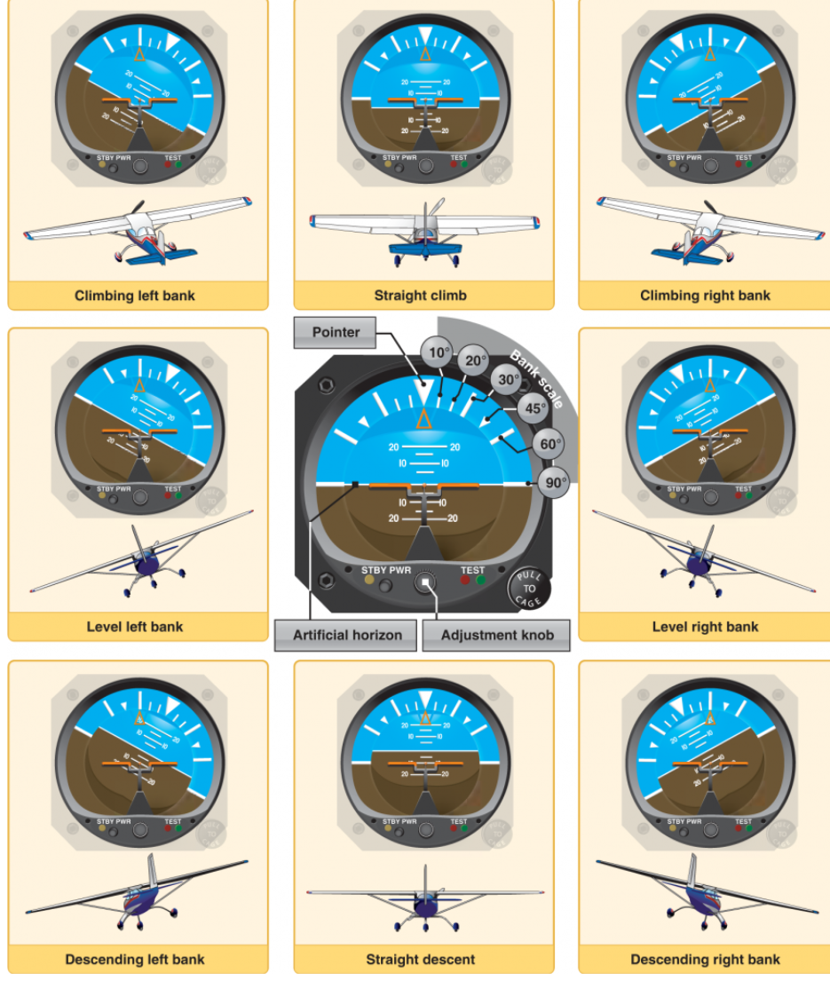

* **Heading Indicator:** A gyroscopically stabilized compass style card that shows the change in heading during a turn.
  + **Warning:** It must be adjusted before and during the flight while in steady level flight.
  + **Note:** In some glass panels the Heading Indicator is replaced by a Horizontal Situation indicator (HSI), which automatically realigns itself to the compass directions during flight.

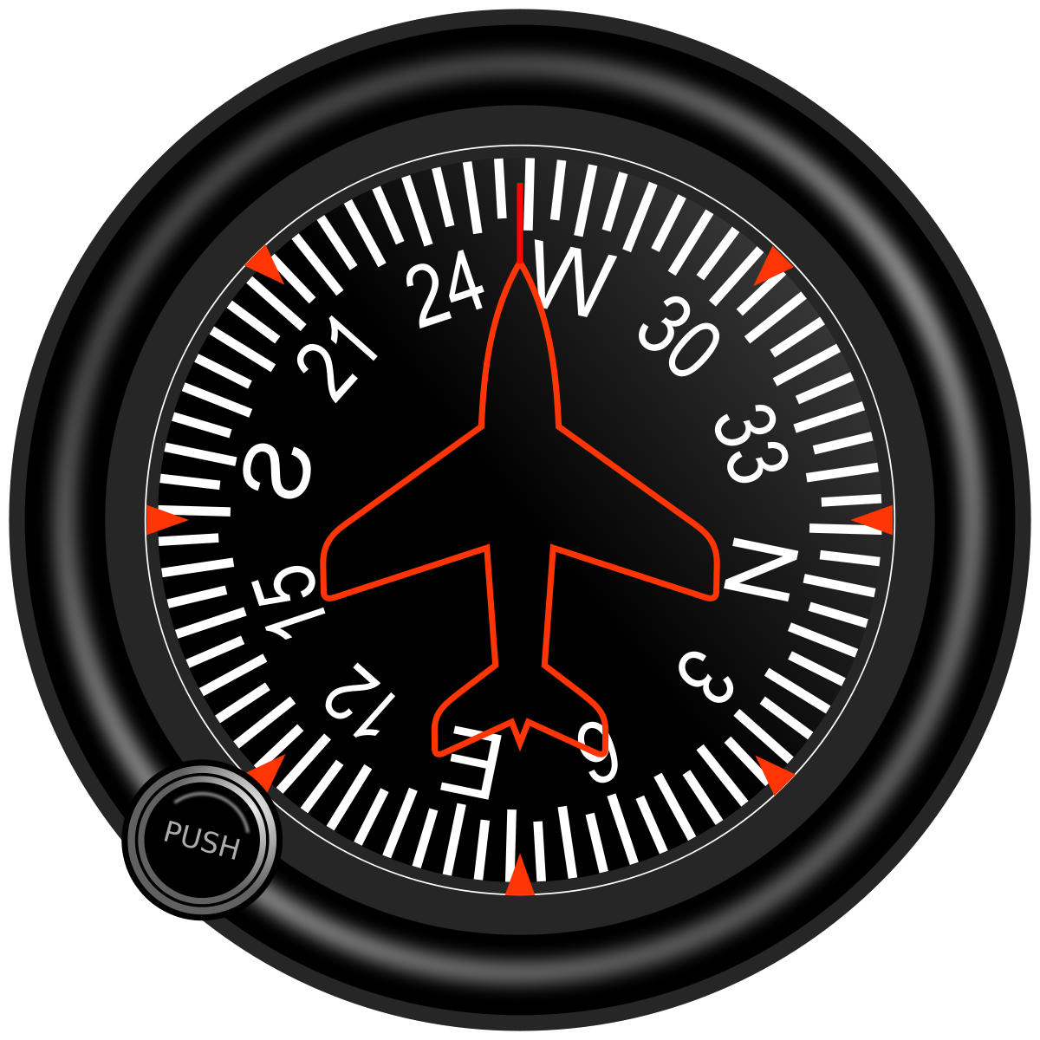

* **Turn Coordinator:** A gyroscopic indicator that shows bank angle, roll rate and has markings for a standard turn of 3 deg/sec.
  + **The inclinometer:** The ball in the tube that shows whether the plane is moving into or outward of the turn/ slipping or skidding. Try to keep this centered during a turn using the rudder.

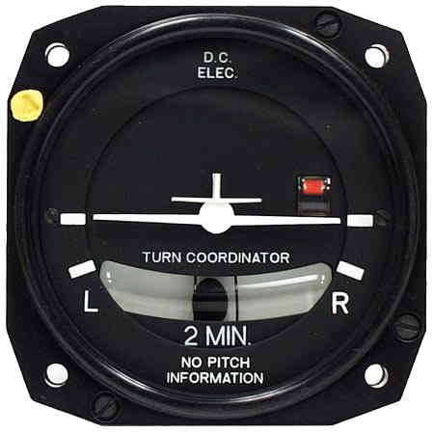

* **The Engine instruments:**
  + **Throttle, Mixture and Propellor Knobs**: Pull back to reduce, Push forward to increase.
  + **Tachometer**: Indicates RPM of the engine
  + **Fuel flow indicator**
  + **Exhaust Gas Temperature gauge**
  + **Fuel selector:** Allows the pilot control which fuel tanks the engine draws off.
  + **Fuel shutoff valve**
  + **Clock, Voltmeter**

**Lesson 7 - 8: Introduction to Airplane Engines**

* **Typical Training Plane Engine:** 4 stroke Reciprocating engine
  + **Cylinders:** House the piston and gases to combusted
  + **Pistons:** Move inside the cylinder to create mechanical power
  + **Connecting rods:** Connect pistons to crankshaft
  + **Crankcase:** The metal case/shell
  + **Two Spark plugs per cylinder:** One for backup
* **Engine Cycle**
  + **1. Intake stroke:** Piston moves in towards the crankshaft and fuel air mixture enters the cylinder
  + **2.** **Compression Stroke:** Piston compresses the gas inside the cylinder
  + **3.** **Power Stroke:** The mixture inside the cylinder is ignited and expands moving the piston.
  + **4. Exhaust Stroke**: The piston compresses again and pushes the spent gas out of the cylinder.
* Most heat is expelled through the exhaust system.
* **Engine oil functions**
  + 1. Coats and lubricates engine components
  + 2. Reduces engine temperature
  + 3. Carries debris away from the engine and toward the filter.
* In warm weather wait 4 minutes before applying full throttle to let the engine oil heat up and pressurize properly. In Cold weather wait 6.
* **Dual Magneto Ignition System:** Uses magnetos driven by the engine to light the spark plugs for the engine.
  + Makes the engine independent of the of the plane’s battery.
  + Check both magnetos according to your AFM during engine runup before the run way.
  + Turn the magneto switch to both during flight and off to shut down the engine.
  + Always wait between 30 seconds to a minute before using the starter successively.

**Lesson 9: Propellor, Fuel, and Electrical System**

* Cessna uses a wet wing design (integral fuel tanks with the wing ) which have cap vents.
* 5 drain valves are below each wing.
  + Note: some airplanes may only have 1 drain.
* Always drain the tanks, with a special tool, before each flight to expel water or sediment trapped in the tank.
* GA planes typically use Avgas 100LL which is blue in color

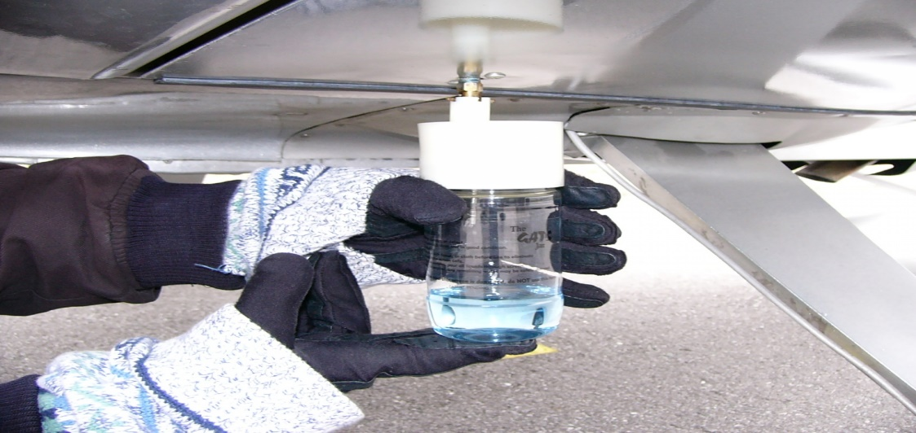

* Check the planes manual for the proper fuel and never use the wrong fuel in the plane or you may face engine failure.
* Normal gasoline (Mogas) can only be used if you have a secondary type certificate for the plane.

**Cessna fuel system**

* Fuel flows out of the tanks through gravity into the selector valve.
* There is an engine driven pump and an electric auxiliary pump
* The electric pump is usually used to prime the engine cylinders before activation.
* After going through the electric pump the fuel travels through the shutoff valve, a filter/strainer, the engine driven pump, and then a fuel air control unit and distribution valve.

**Propellor**

* Propeller is twisted to ensure constant thrust at each length of the blade during spin.
* Increasing the throttle increases engine rpm.

**Electrical system**

* Most electronics are driven by a 24 volt battery and alternator.
* There is a master switch panel with a red battery and alternator switch each to be pressed at the same time to activate the electrical system buses.
* Next there are two white switches for the activation of the avionics busses.
* **Electrical bus 1**: Glareshield, overhead, courtesy, landing and flashing beacon lights, flaps, instrument and ignition switch, fuel pump and 12 volt power.
* **Electrical bus 2:** Turn coordinator, nav, control wheel, map, instrument, strobe and taxi lights; and pitot heat.
* **Avionics bus 1:** Avn Fan, GPS, HSI, and audio panel 1
* **Avionics bus 2:** Audio panel 2, transponder, autopilot, and ADF.
* There is a voltmeter and ammeter for the electric system and safety fuses for individual components.
  + **Warning:**  A negative ammeter value indicates the battery is losing power and there may be overload or malfunction of the system.

**Lesson 10: Carbureted Engines**

* For starting on a cold day, a **primer pump** is used to fill the carb and cylinders
* Light sport planes may use a **choke** instead.
* At low temperatures the carburetor can ice reducing if not killing engine performance.
* The carburetor heater is used to melt ice that may build up inside the tube when flying below 70 F.
* Icing may be indicated by a sudden loss of engine rpm in steady level flight.
* Apply full carb heat immediately if icing is suspected, it will reduce engine rpm by a bit.

**Lesson 11: Preflight**

* Inspection starts as you walk up to the plane.
* Look for damages, fuel/oil leaks, flat tires and ice.
* Use a preflight inspection checklist
* If you see dents in control surfaces, cracks or missing rivets and have a professional check them over before flying.
* Move control surfaces gently with your hands.
* **Required Aircraft Documents:**
  + Airworthiness certificate
  + Registration
  + Operating handbook
  + Weight and Balance info
* Remove the control lock and turn on the master electronics switch and check the engine tanks for reference later.
* Turn on the avionics master switch and listen for the fan noise.
* Turn on the engine pump and lights and confirm that the beacon and other lights are on outside.
* Lower the flaps and check that they have moved.
* Turn off the electronics and move around the plane clockwise and inspect it for damage and move the control surfaces.
* Check the static port is clear.
* Check the fuel tanks for the correct amount of fuel.
* Sump the fuel tanks and make sure the fuel is blue and free of water or sediment.
* Check the wheels and brakes for bald spots and brake fluid leaks.
* Check the engine for the right amount of oil
* Check for no debris in the cowling or the induction filter.

**Lesson 13: Engine starting**

1. Set the parking brake and press on the foot brakes.
2. Adjust seats and seat belts.
3. Fuel selector valve on both, and shut off valve is in
4. Avionics master switch is off. Circuit breakers are in.
5. Check that no one is nearby.
6. Open throttle a quarter inch and mixture at idle cutoff.
7. Turn on beacon and then master switch.
8. Call “Clear” outside to warn others
9. Turn on the fuel pump.
10. Prime the pump by pushing the mixture to the point of 3 Gallons/hour
11. Pull mixture to idle and turn off pump.
12. Turn the key to start and advance the mixture to full rich.
13. Wait 30 seconds for the oil pressure to reach green. If it doesn’t shut off the plane and get a specialist.
14. Turn on the avionics master, raise the flaps, and activate necessary lights.

**Lesson 14: Aviation Communications**

* **You can activate the radio using the button behind the Yoke or by pressing the button on top of the hand held radio.**
* English is the international language of aviation
* The AIM (Aeronautical Information Manual) is the official source of radio comms procedure.
* Say any letters using the **phonetic alphabet** created by the ICAO(International Civil Aviation Manual).
* Numbers may have special pronunciation: 5 = Fife, 9 = Niner, 3 = Tree
* Say any decimals as point
* **Altitude reports:**
  + Pronounced in thousands and then hundreds
  + i.e. 9,500 ft = “Niner Thousand Fife Hundred feet”
  + Pronounce individual digits for numbers under 100.
  + Above 18,000 ft are called flight levels
  + i.e. 23,000 ft = “Flight level Two Tree Zero”
* **Heading, Bearing, or Wind Direction**
  + Must be said in each individual digit
  + i.e. 270 degree = “Heading Two Seven Zero”
  + All are in relation to magnetic direction unless the word **TRUE** is spoken.
* **Speed**
  + Should also be expressed as separated digits
  + I.e. 100 = “One Zero Zero Knots”
  + Knots can be omitted to save time.
* **Time**
  + Typically expressed in Universal Time Coordinated (UTC) aka “Zulu Time”
  + Can also be expressed as local time if the word **LOCAL** is said
* **Air Traffic**
  + Reported in relation to the direction your aircraft is tracking using a clock
  + i.e. Traffic in front of your velocity direction = “at your twelve o’clock”
* All Registered aircrafts have an N on them so do not say the N as November when telling who you are on radio
* **Roger =** “I have received your message”
* **Affirmative = “**Yes**”**
* **Negative = “**No**”**
* **Wilco = “**I have received your message and will comply**”**
* **The 4 W’s of talking on the radio**
  + **Who**: are you calling
  + **Who**: you are
  + **Where:** you are
  + **What:** you want todo
* **Unicom: Unified Communications** 
  + A non-government radio station usually available at non towered airport or fields
  + Call them by including, Unicom in the initial who you are calling
  + Warning: They are not always attended so always be ready to watch for other airplanes.
  + Can include the airport CTAF(Common Traffic Advisory Frequency)

**Lesson 16: Taxi, Run-up, Traffic Pattern**

* You steer the plane on the ground using the rudder pedals
* To use the brakes step on the top of the pedals
* Right pedal = Right turn, Left pedal = Left turn
* Use the pedal brakes to supplement the turn
* Keep the taxi speed slow enough for the plane to stop without the brakes
* **Taxi controls in heavy wind conditions:**
  + **Left quartering headwind:** Move ailerons fully to the left and keep elevator neutral
  + **Right quartering headwind:** Move ailerons fully to the right and keep elevator neutral
  + **Left quartering tailwind:** Move ailerons fully to the right and push yoke forward to keep elevator in the down position
  + **Right quartering tailwind:** Move ailerons to the left and yoke forward

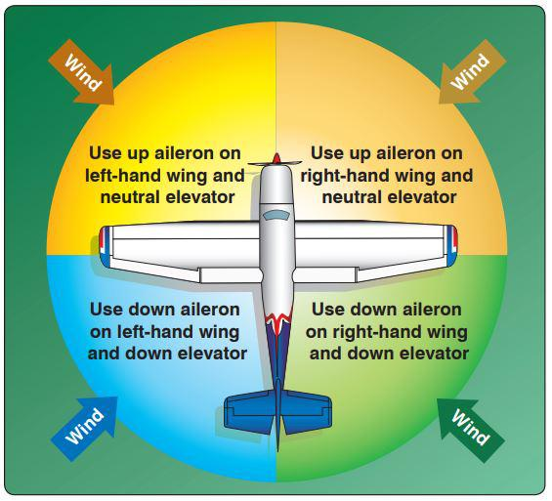

* When you reach the run-up area face your plane heading into the wind
* **Perform the before take-off checklist:**
  + Seatbelts set
  + doors closed and locked
  + flight controls move freely
  + fuel selector set to both
  + shut-off valve is in
  + Trim position is set to take off position
  + Mixture set too rich
  + Start the engine
  + Set rpm to 18000
  + Switch on each set of magnetos individually by turning the key to each one and observe a decrease of about 150 rpm.
  + Turn on the proper lights and check the ammeter
  + Check oil pressure and temperature
  + Return throttle to idle
  + Check and set the flight instruments
* **Left Hand Traffic Pattern**
  + **Upwind leg:** Direction the plane flies during takeoff, into the wind.
  + **Crosswind leg:** Flown 90 degrees to the landing runway and off the takeoff leg
  + **Downwind Leg:** Parallel to the landing runway and flown opposite to landing direction
  + **Base Leg:** 90 degrees to the runway flown on the approach end
  + **Final leg:** Flown while aligned with the runway and landing
* Exiting the pattern is done at pattern altitude either straight out at a 45 degree turn into the pattern direction
* Runways numbers are determined from the **approach direction and its magnetic compass direction.**
* Some airports can have a Left, Right and center runway indicated by an L, R, or C respectively
* Wind directions reported by ATC are magnetic for comparison with the runway

**Lesson 17: Wind Direction Indicators**

You should always take off and land into the wind!

1. **Wind Sock:**

* Small part of the sock points into the wind

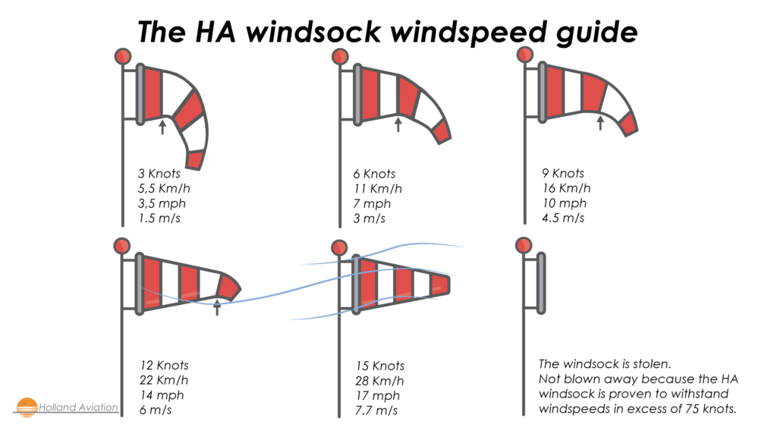

1. **Wind Tee**

* Vertical stabilizer points in the wind direction

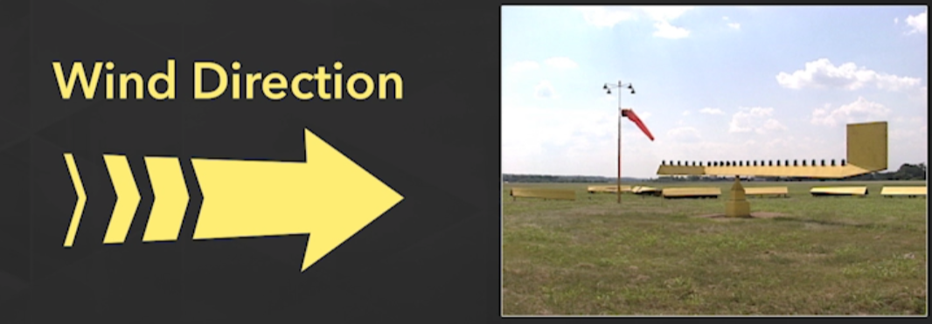

1. **Tetrahedron**

* Large part faces the wind direction.
* Pointer faces the direction of landing/takeoff

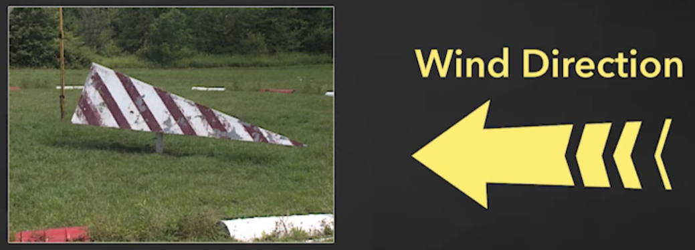

* Some airports have weather observing systems such as Automated Weather Observing System(**AWOS**)or Automated surface observing System (**ASOS**) that can report the wind over radio frequency.

**Lesson 18: Takeoff**

* First announce on the CTAF that you are taxiing onto the active runway.

**Process**

1. Advance throttle smoothly to full.
2. Pick an aiming point down the centerline to focus on
3. Maintain direction using the rudder pedals and counter left turning tendency
4. Wait until takeoff speed and then slightly pull back on the yoke
5. Accelerate to target climb speed and then trim the plane to fly at it
6. Do Not make any turns before getting to 500 ft above ground.
7. Begin making a turn to crosswind at 300 ft before reaching traffic pattern altitude
8. Watch for and avoid any other air traffic as you enter/exit the pattern

**Lesson 22: Four fundamental Flight Maneuvers**

**Turn, Straight and Level, Climbs, and Descents**

* Control Depends on power setting, pitch, and bank in relation to references outside the plane.
* **Attitude:** The airplane’s position relative to the horizon
  + Primary outside reference is a point on the plane vs a point on the horizon
  + Inside reference is typically the plane on the artificial horizon
  + The altimeter, heading indicator, airspeed indicator, and turn coordinator are used to cross check the attitude displayed on the attitude indicator.
  + Is controlled using pitch, bank and power

**Turns**

* Involve use of all primary controls of the airplane, ailerons, rudder, and elevator
* **Shallow Bank < 20 $°$:** Hold control pressure to prevent airplane from un-banking
  + Rollout at 10 degrees before desired heading
* **20 $°$ < Medium Bank < 45 $°$:** Neutralize controls to maintain bank
  + Rollout 15 degrees before
* **Steep Bank > 45 $°$:** Controls should be turned the opposite to avoid over-banking
  + Rollout 25 degrees before
* The aileron goes up on the side you turn the yoke/stick towards.
* The horizontal component of lift causes the turn in a bank.
* **Adverse Yaw:** The yaw of a plane to the outside of the turn.
  + Counteract with opposite rudder to maintain coordination
* Use the wings of the plane relative to the horizon as reference
* Always look for other planes and clear the area before turning
* **Elevator back pressure or extra power must be added during a turn** 
  + **Pitch increases during turn =** Too much elevator pressure is used
  + **Pitch decreases =** Not enough elevator back pressure
* **Turn coordinator and Inclinometer:**
  + **Slipping =** Ball is on the inside of the bank; plane loses altitude.
  + **Skidding =** Ball is on the outside of the bank;plane gains altitude and moves outward of the turn.
  + **Coordinated flight:** Ball is centered in the middle.

**Lesson 24: Four fundamentals part 2**

**Straight and Level Flight:**

* Maintains a constant attitude, vertical altitude, and heading.
  + Check the altimeter to ensure constant altitude and ensure attitude
  + Pick a reference point on the nose and keep it constant to the horizon
  + Cross reference the positions of the wings in relation to the horizon to check attitude
  + Trim the plane to maintain straight flight
  + **Vertical Speed indicator** has a 6 second lag to actual vertical speed
  + **Power** controls the plane altitude and **Pitch** controls speed
  + Attitude Indicator, Heading Indicator, and Turn Coordinator are reference instruments

**Climbs:**

* Uses pitch and power to increase altitude
* **Normal Climb:** Airspeed and power made to have the most efficient gain of altitude
* Pull back on the controls, increase power simultaneously and reach intended climb speed.
* Use the rudder to counteract left turning tendency
* Climbing turns should be made with shallow banks for safety
* Start to level off/lead about 50 ft before desired altitude or 10 percent current climb velocity

**Descents:**

* Pitch is used to lose altitude
* Gliding is the unpowered variant
* **Normal Glide:** Pitch is used to keep plane at an airspeed to maximize glide distance
  + Usually, general aviation planes have a glide ratio of 9:1
* Clear the engine by throttling the engine to 1500 rpm every 30 seconds during descent
* To start the glide reduce power until l normal glide speed is attained and then control pitch to maintain it.
* Lead 50 to 100 ft before target altitude.

**Lesson 25: The Proper Attitude**

* An airplane can stall at any airspeed and any attitude.
* Never abruptly shift the airplane’s attitude or you could cause a stall
* Look at the pitch attitude of the plane and then the vertical speed indicator to confirm whether or not it is ascending or descending. If the nose is up but the plane is descending the AOA is to high.
* Always make smooth and gentle changes in the airplane’s movement.